Capstone Project Final Report

Submitted to
Faculty of Engineering and Natural Sciences
Department of COMPUTER ENGINEERING

In partial fulfillment of the requirements for the degree
BACHELOR of SCIENCE in COMPUTER ENGINEERING

LSTM-Based Host Intrusion Detection on Linux System Call Sequences

Student: Emirhan Müftüoğlu | Muhammet İsmail Kurtuluş
ID Number: 200722102 | 210901045

Supervisor(s): Sedat Akleylek

Istanbul
May 2026
STUDENT DECLARATION

By submitting this report, as partial fulfillment of the requirements of the Capstone Project, the students promise on penalty of failure of the course that
- They have given credit to and declared (by citation), any work that is not their own (e.g. parts of the report that is copied/pasted from the Internet, design or construction performed by another person, etc.),
- They have not received unpermitted aid for the project design, construction, report or presentation,
- They have not falsely assigned credit for work to another student in the group, and not take credit for work done by another student in the group.

Abstract
This capstone project investigates whether anomalous Linux process behavior can be detected from system call sequences learned under normal operating conditions. The study is conducted as a single-scenario case study on the LID-DS 2021 dataset using the PHP_CWE-434 scenario. An end-to-end offline host-based intrusion detection pipeline is implemented, including trace parsing, preprocessing, thread-based window generation, sequence encoding, and trace-level decision making. Three methods are compared: a classical STIDE baseline, an LSTM syscall-only next-token predictor, and an LSTM context-aware next-token predictor that combines syscall, process, and return-status context. Window scores are aggregated into trace scores using top-10% mean pooling, and operating thresholds are derived from validation-normal quantiles (q95 as the primary operating point and q90 as sensitivity analysis). At q95, the LSTM Syscall model achieves the best balanced performance (Precision 0.9469, Recall 0.9386, F1 0.9427, FPR 0.0079, AUC 0.9962), while LSTM Context reaches perfect recall but with higher false positives. The findings show that deep sequence models can improve recall without sacrificing low false-positive behavior when calibrated carefully, yet the prototype remains an offline, single-scenario study and should not be over-generalized to production-scale real-time deployment.

Keywords: Host-Based Intrusion Detection; System Calls; LSTM; Anomaly Detection; LID-DS 2021.
Table of Contents
1. Introduction 2
1.1 Background and Motivation 2
1.2 Problem Statement 2
1.3 Research Aim and Objectives 2
1.4 Research Questions 2
1.5 Contributions 2
1.6 Scope and Limitations 3
1.7 Structure of the Report 3
2. Literature Review 5
2.1 Host-Based Intrusion Detection and System Call Signals 5
2.2 Classical Sequence-Based Detection (n-grams, STIDE, and Related) 5
2.3 Statistical and Machine Learning Extensions 5
2.4 Deep Learning and Sequence Modeling for HIDS 5
2.5 Datasets and Benchmark Evolution 5
2.6 Thresholding, Evaluation, and False Positives 6
2.7 Literature Comparison Table 6
2.8 Research Gap 7
3. Methodology 9
3.1 Research Design 9
3.2 Dataset and Case Description 9
3.3 Parsing and Preprocessing Pipeline 9
3.4 Thread-Based Window Construction 9
3.5 Feature Encoding 9
3.6 Models and Training Configuration 9
3.7 Trace-Level Aggregation and Thresholding 10
3.8 Evaluation Metrics 10
3.9 Implementation Environment and Repository Structure 10
3.10 Dataset and Experimental Setup Summary 10
4. Results 13
4.1 Experimental Setup and Operating Points 13
4.2 ROC-AUC Summary 13
4.3 Main Comparison at Validation-Normal q95 14
4.4 Confusion Matrix and Score Distribution Analysis 14
4.5 Sensitivity Analysis with q90 Thresholds 18
4.6 Original Thresholding and Reliability Summaries 18
4.7 Summary of Findings 19
5. Discussion and Conslusion 21
5.1 Discussion of Key Findings 21
5.2 Practical Implications 21
5.3 Limitations 21
5.4 Future Work 21
5.5 Conclusion 21

List of Tables
Table 1 Literature comparison summary for representative HIDS studies. 6
Table 2 Dataset and experimental setup used in this project. 10
Table 3 ROC-AUC comparison on test traces. 13
Table 4 Main trace-level comparison at validation-normal q95 thresholds. 14
Table 5 Sensitivity comparison at validation-normal q90 thresholds. 17
Table 6 Original validation-based thresholding comparison (supporting). 18
Table 7 Bootstrap q95 reliability summary (mean metrics). 18
Table 8 Error analysis summary at q95. 18

List of Figures
Figure 1 Combined ROC curves for STIDE, LSTM Syscall, and LSTM Context. 13
Figure 2 STIDE confusion matrix at q95. 15
Figure 3 LSTM Syscall confusion matrix at q95. 16
Figure 4 LSTM Context confusion matrix at q95. 17
Figure 5 STIDE trace-score distribution. 17
Figure 6 LSTM Syscall trace-score distribution. 18
Figure 7 LSTM Context trace-score distribution. 18
Figure 8 Example false-positive trace profile (q95, LSTM Syscall). 24

List of Abbreviations
IDS | Intrusion Detection System
HIDS | Host-Based Intrusion Detection System
LSTM | Long Short-Term Memory
STIDE | Sequence Time-Delay Embedding
ROC | Receiver Operating Characteristic
AUC | Area Under the Curve
FPR | False Positive Rate
TP | True Positive
TN | True Negative
FN | False Negative
CSV | Comma-Separated Values

Section 1:
Introduction

1. Introduction

1.1 Background and Motivation
Host-based intrusion detection systems (HIDS) analyze internal host behavior to detect suspicious activity that may bypass perimeter defenses. Linux system calls provide fine-grained behavioral signals because every user-space process eventually interacts with the kernel through syscall interfaces. This makes syscall traces a strong candidate for anomaly detection studies, especially for control-flow deviations and attack-related execution patterns (Forrest et al., 1996; Hofmeyr et al., 1998; Warrender et al., 1999).

1.2 Problem Statement
Many anomaly-based HIDS studies report high detection rates, but practical performance is often sensitive to data splitting policy, threshold selection, and false-positive control. The project problem addressed here is to build and evaluate a trace-level anomaly detection pipeline that is reproducible and transparent for a modern Linux syscall dataset scenario, while preventing overclaims beyond available evidence.

1.3 Research Aim and Objectives
Aim: to evaluate whether anomalous Linux process behavior can be reliably detected from normal syscall patterns in an offline host-based setting. Objectives are: (i) build an end-to-end data processing and evaluation pipeline; (ii) compare STIDE with LSTM-based predictors; (iii) compare syscall-only and context-aware representations; (iv) calibrate thresholds with validation-normal quantiles; and (v) analyze error patterns and limitations.

1.4 Research Questions
RQ1: Can anomalous Linux process behavior be reliably detected from normal patterns learned from system call sequences? RQ2: How does a classical STIDE baseline compare with LSTM-based next-token prediction under trace-disjoint evaluation? RQ3: Does adding process and return-status context improve detection trade-offs at trace level?

1.5 Contributions
The project contributes: (1) a reproducible offline pipeline from raw traces to trace-level decisions; (2) explicit trace-disjoint split checks; (3) a controlled comparison between STIDE, LSTM Syscall, and LSTM Context; (4) top-10% mean pooling for trace aggregation; and (5) report-ready final tables, figures, and a local Streamlit demonstration component for analyst-facing inspection.

1.6 Scope and Limitations
This report is a single-scenario case study (LID-DS 2021, PHP_CWE-434) and an offline prototype. It does not claim real-time deployment readiness. Generalization to other scenarios, organizations, or threat landscapes is not guaranteed without additional multi-scenario and operational validation.

1.7 Structure of the Report
Section 2 reviews related literature and identifies the project gap. Section 3 details the data, models, and evaluation design. Section 4 presents quantitative findings with sensitivity and error analysis. Section 5 discusses implications, limitations, and future work.

Section 2:
Literature Review

2. Literature Review

2.1 Host-Based Intrusion Detection and System Call Signals
HIDS research has evolved from rule-based monitoring to statistical and machine learning approaches that model normal host behavior and detect deviation. System calls remain a central source because they encode low-level program behavior with strong semantic relevance for host compromise analysis (Bridges et al., 2019; Hofmeyr et al., 1998).

2.2 Classical Sequence-Based Detection (n-grams, STIDE, and Related)
Foundational works modeled short syscall subsequences and mismatch behavior to detect anomalies (Forrest et al., 1996; Warrender et al., 1999). STIDE-style approaches remain competitive when tuned carefully, and operational behavior is strongly tied to n-gram length and threshold calibration (Tan & Maxion, 2002). Evasion studies such as mimicry attacks also showed that feature design and context can materially affect robustness (Wagner & Soto, 2002).

2.3 Statistical and Machine Learning Extensions
Beyond fixed n-gram matching, studies explored automata, hidden Markov models, and richer statistical features (Sekar et al., 2001; Liao & Vemuri, 2003; Hu et al., 2009; Hoang et al., 2009; Ye et al., 2001; Ye et al., 2002). These approaches improved representation power but also highlighted sensitivity to data quality, split methodology, and deployment assumptions.

2.4 Deep Learning and Sequence Modeling for HIDS
Recent work frames syscall traces as language-like sequences and applies neural sequence models. LSTM-based system-call language modeling demonstrated strong anomaly discrimination and emphasized the role of thresholding for false alarm control (Kim et al., 2016). Later studies examined representation choices, including abstraction and context enrichment, with measurable trade-offs between recall and false positives (Wunderlich et al., 2020; Lv et al., 2021).

2.5 Datasets and Benchmark Evolution
Dataset quality is a major bottleneck in HIDS research. ADFA-LD and its follow-up evaluations addressed limitations of older corpora but still exposed issues of comparability and representational depth (Creech, 2014; Xie & Hu, 2013; Xie et al., 2014a; Xie et al., 2014b). LID-DS introduced modern scenario design and later expanded metadata richness and tooling support, including thread-level context and standardized processing workflows (Pendleton & Xu, 2017; Grimmer et al., 2019; Grimmer et al., 2022; Grimmer et al., 2023).

2.6 Thresholding, Evaluation, and False Positives
Across studies, high ranking performance does not automatically translate into stable operational decisions. Threshold policy directly shapes false positive rate and analyst workload. Therefore, reportable IDS studies should separate ranking quality (e.g., AUC) from operating-point behavior (precision/recall/FPR/accuracy), and should disclose threshold sensitivity explicitly (Bridges et al., 2019; Talhi, 2017).

2.7 Literature Comparison Table

Table 1 Literature comparison summary for representative HIDS studies.
Study | Dataset | Method | Key Finding | Limitation | Relevance to this project
Forrest et al. (1996) | UNIX traces | Short syscall sequences | Early self/non-self process profiling | Limited modern context | Foundation for sequence anomaly detection
Hofmeyr et al. (1998) | UNM-like syscall data | Sequence-based anomaly detection | Established syscall-sequence IDS paradigm | Older workloads | Baseline theory for HIDS pipelines
Warrender et al. (1999) | System-call benchmark data | STIDE/HMM/RI comparison | Alternative sequence models compared | Dataset age and scope | Motivates classical baselines
Sekar et al. (2001) | Program syscall sequences | Automaton-based detection | Efficient sequence anomaly modeling | Program-specific modeling cost | Efficiency considerations
Tan & Maxion (2002) | STIDE settings | Operational limit analysis | Showed sensitivity to n-gram size | Context-limited setup | Supports careful n choice
Hu et al. (2009) | Host syscall data | HMM-based anomaly detection | Simple efficient HMM scheme | Requires calibration and feature tuning | Statistical sequential baseline
Creech (2014) | ADFA-LD | Semantic system-call patterns | Improved detection on modern attacks | Dataset-specific dependence | Modern benchmark transition
Kim et al. (2016) | Public syscall datasets | LSTM language modeling | Strong deep sequence modeling potential | Threshold tuning needed | Direct LSTM relevance
Grimmer et al. (2022) | LID-DS | Thread-aware extensions | Thread information improves HIDS | Scenario dependence | Supports thread-based construction
Wunderlich et al. (2020) | ADFA-LD & LID-DS | Representation comparison | Representation impacts outcomes | No universal mapping | Supports representation ablation
Park et al. (2021) | LID-DS | Siamese network | Few-shot class-discrimination potential | Different objective | Related LID-DS deep approach
Grimmer et al. (2023) | LID-DS 2021 | Dataset/framework report | Improved metadata and tooling | Still synthetic scenarios | Primary dataset reference

2.8 Research Gap
The literature shows strong algorithmic progress, but comparisons are often not directly transferable due to inconsistent split policies, threshold definitions, and trace-level aggregation choices. This capstone addresses that gap at undergraduate scope by implementing a transparent, trace-disjoint, single-scenario comparison on LID-DS 2021 (PHP_CWE-434), with STIDE, LSTM Syscall, and LSTM Context evaluated under aligned trace-level scoring and validation-normal quantile thresholding.

Section 3:
Methodology

3. Methodology

3.1 Research Design
The project follows an experimental comparative design using one classical baseline and two LSTM-based models. The study is an offline trace-level anomaly detection case study, not a real-time production deployment experiment.

3.2 Dataset and Case Description
Dataset: LID-DS 2021. Scenario used in this repository: PHP_CWE-434. Input traces are Linux system-call records processed into labeled windows and aggregated at trace level. Split handling is trace-disjoint, and validation attack traces are separated from test attack traces in pipeline logic and split-check scripts.

3.3 Parsing and Preprocessing Pipeline
Raw .sc traces are parsed into structured records (timestamp, cpu_id, thread_id, process_name, process_id, syscall, direction, result). Cleaning enforces required fields, valid directions, numeric conversion, and derives return_status from syscall result values. Warmup filtering is applied using scenario metadata, then windows are generated per thread.

3.4 Thread-Based Window Construction
Windows are built by grouping events by thread_id, sorting by timestamp, and applying a sliding window of size 30 with stride 1. Windows crossing exploit boundaries are discarded by label assignment logic: windows ending before exploit time are normal, windows starting at/after exploit time are anomaly, and crossing windows are removed.

3.5 Feature Encoding
Two representations are used for LSTM models: (i) syscall-only token sequences from window_syscalls, and (ii) context tokens combining syscall_name, process_name, and return_status triplets. Vocabularies are built from training data with PAD and UNK tokens, and training data encoding is capped at 500,000 windows.

3.6 Models and Training Configuration
STIDE uses n-gram size n=6 and mismatch ratio scoring. LSTM models use next-token prediction with embedding dimension 64, hidden dimension 128, one LSTM layer, dropout 0.2, batch size 256, Adam optimizer (lr=1e-3), CrossEntropyLoss with PAD ignored, and 10 epochs. Training uses normal windows only (only_normal=True), while evaluation includes normal and attack traces.

3.7 Trace-Level Aggregation and Thresholding
Window anomaly scores are aggregated to trace-level scores via top-10% mean pooling. For a trace with window scores s_(1) >= s_(2) >= ... >= s_(n), k = ceil(0.10*n), and trace_score = (1/k) * sum_{i=1..k} s_(i). Primary operating thresholds are validation-normal q95 values; q90 is used as sensitivity analysis. Original validation-based thresholding is retained only as supporting comparison.

3.8 Evaluation Metrics
Precision = TP/(TP+FP), Recall = TP/(TP+FN), F1 = 2*(Precision*Recall)/(Precision+Recall), FPR = FP/(FP+TN), Accuracy = (TP+TN)/(TP+TN+FP+FN). ROC-AUC is reported as threshold-independent ranking quality.

3.9 Implementation Environment and Repository Structure
Implementation is Python-based with modular source folders: parsing, preprocessing, pipeline, baseline, lstm, reporting, and demo. Final report figures and tables are generated from dedicated reporting scripts and exported under results/final_figures and results/final_tables.

3.10 Dataset and Experimental Setup Summary
Table 2 Dataset and experimental setup used in this project.
Item | Configured value
Dataset | LID-DS 2021
Scenario | PHP_CWE-434
Detection setting | Offline trace-level anomaly detection prototype
Input signals | Linux system call traces
Core fields | syscall_name, process_name, return_status, thread_id
Window generation | thread_id grouping, window=30, stride=1
Boundary rule | Exploit-crossing windows discarded
Models | STIDE (n=6), LSTM Syscall, LSTM Context
Training policy | Normal windows only
Train cap | 500,000 windows for LSTM training/encoding
LSTM config | emb=64, hidden=128, layers=1, dropout=0.2
Optimizer/loss | Adam lr=1e-3, CrossEntropyLoss(ignore PAD)
Batch/Epoch | 256 / 10
Trace aggregation | Top-10% mean pooling
Main threshold | Validation-normal q95
Sensitivity threshold | Validation-normal q90

Section 4:
Results

4. Results

4.1 Experimental Setup and Operating Points
The main operating point is validation-normal q95 thresholding for all three models. Fixed q95 thresholds are STIDE=0.145818, LSTM Syscall=0.895200, and LSTM Context=1.067240. Sensitivity analysis uses q90 thresholds: STIDE=0.054867, LSTM Syscall=0.575347, and LSTM Context=0.915675.

4.2 ROC-AUC Summary

Table 3 ROC-AUC comparison on test traces.
model | auc_roc
STIDE | 0.9947
LSTM Syscall | 0.9962
LSTM Context | 0.9915

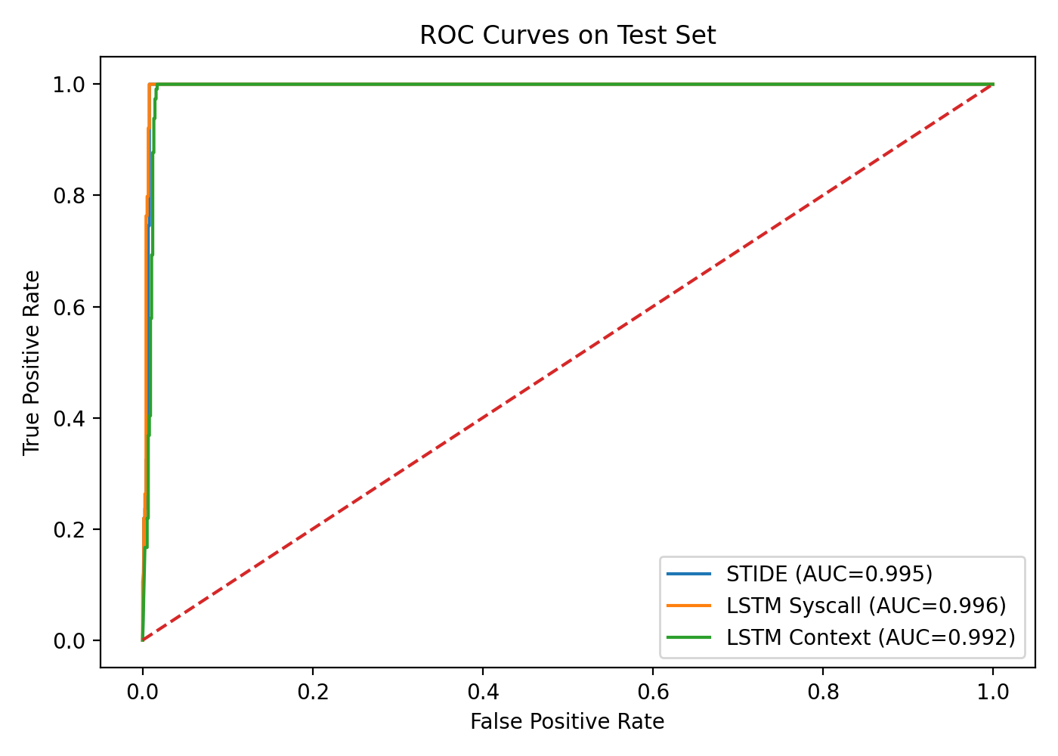
Figure 1 Combined ROC curves for STIDE, LSTM Syscall, and LSTM Context.

All three models achieve AUC above 0.99 on this test set, indicating strong ranking ability. However, operating-point metrics still differ materially across threshold policies.

4.3 Main Comparison at Validation-Normal q95

Table 4 Main trace-level comparison at validation-normal q95 thresholds.
model | threshold | precision | recall | f1 | fpr | accuracy | tp | tn | fp | fn
STIDE | 0.1458 | 0.9412 | 0.8421 | 0.8889 | 0.0079 | 0.9726 | 96 | 756 | 6 | 18
LSTM Syscall | 0.8952 | 0.9469 | 0.9386 | 0.9427 | 0.0079 | 0.9852 | 107 | 756 | 6 | 7
LSTM Context | 1.0672 | 0.8976 | 1.0000 | 0.9461 | 0.0171 | 0.9852 | 114 | 749 | 13 | 0
At q95, LSTM Syscall yields the strongest balance: it substantially improves recall over STIDE while preserving the same low FPR (0.0079). LSTM Context reaches perfect recall (1.0000) but with higher false positives (FPR 0.0171). STIDE remains a strong and interpretable baseline.

4.4 Confusion Matrix and Score Distribution Analysis

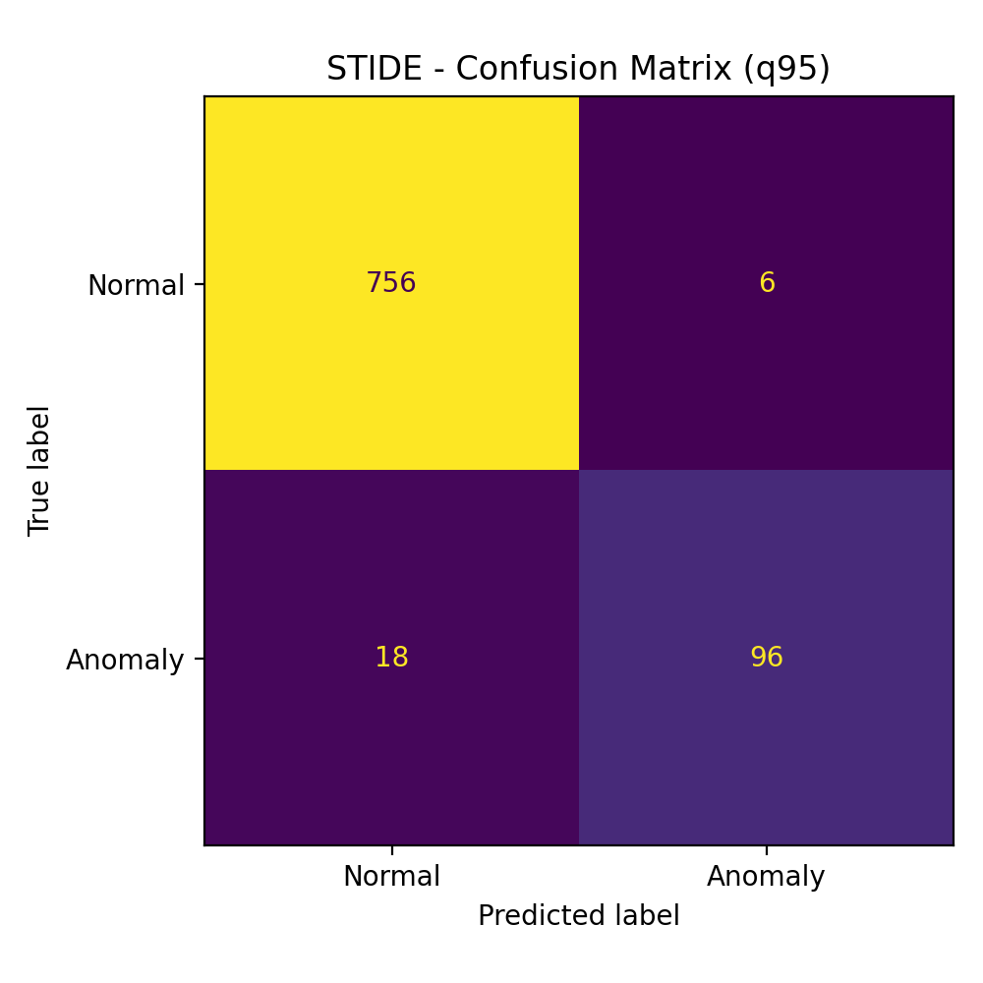
Figure 2 STIDE confusion matrix at q95.

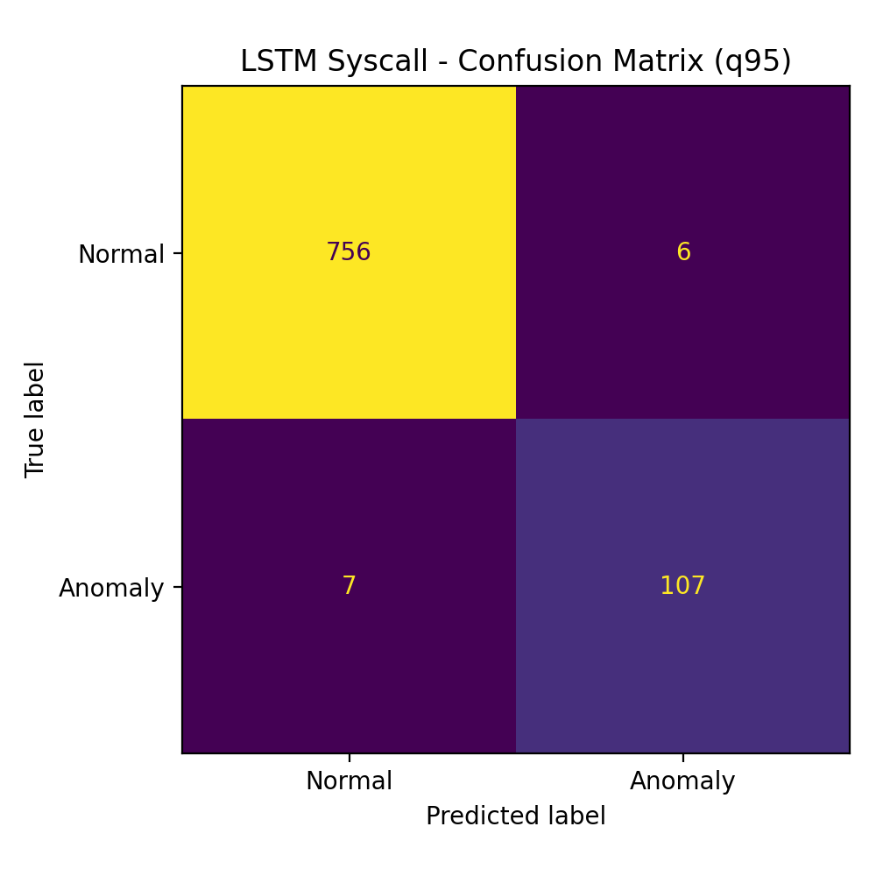
Figure 3 LSTM Syscall confusion matrix at q95.

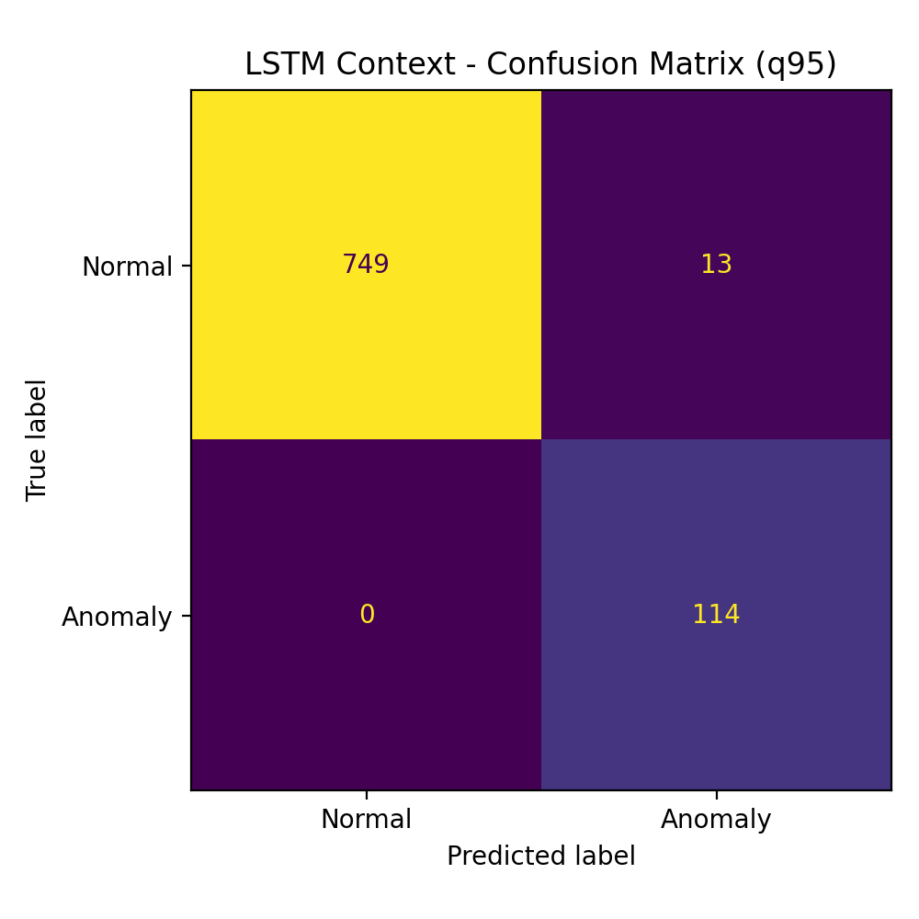
Figure 4 LSTM Context confusion matrix at q95.

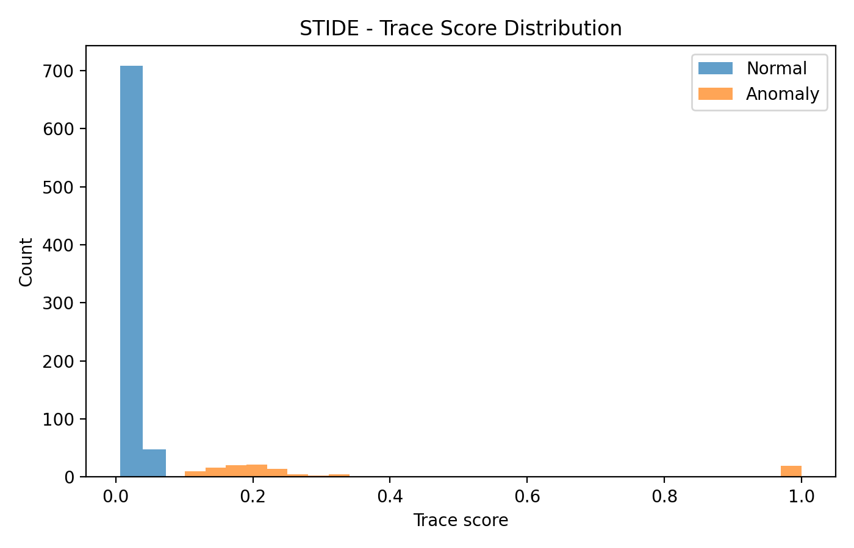
Figure 5 STIDE trace-score distribution.

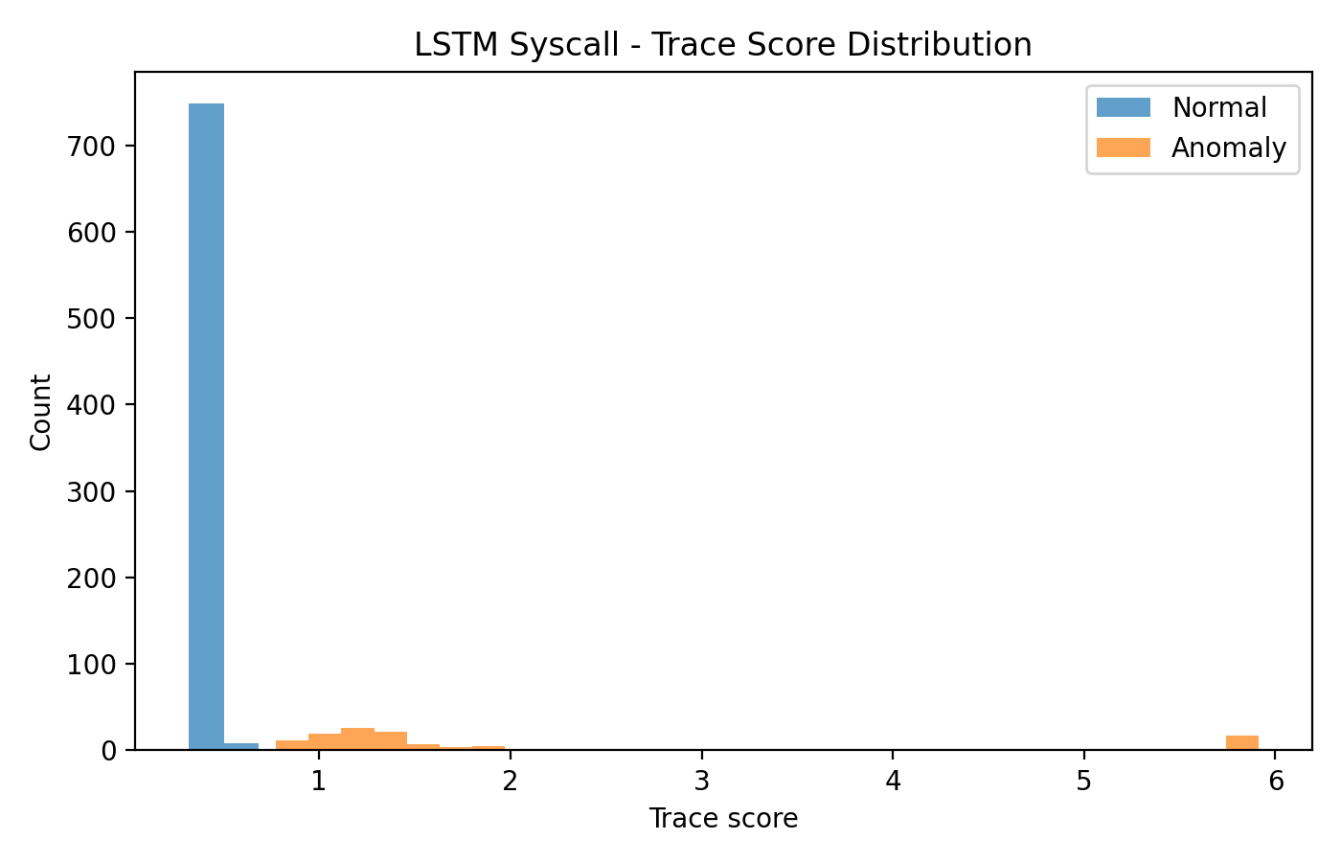
Figure 6 LSTM Syscall trace-score distribution.

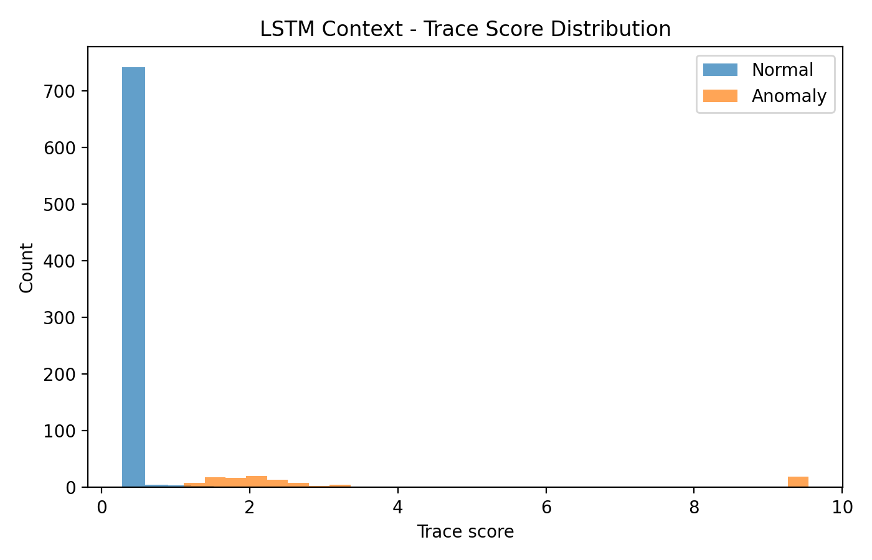
Figure 7 LSTM Context trace-score distribution.

Confusion matrices and score histograms confirm the threshold-level trade-off: context-aware modeling catches all attack traces at q95 but shifts part of normal traffic to false positives. Syscall-only LSTM shows tighter separation under the selected operating point.

4.5 Sensitivity Analysis with q90 Thresholds

Table 5 Sensitivity comparison at validation-normal q90 thresholds.
model | threshold | precision | recall | f1 | fpr | accuracy | tp | tn | fp | fn
STIDE | 0.0549 | 0.9194 | 1.0000 | 0.9580 | 0.0131 | 0.9886 | 114 | 752 | 10 | 0
LSTM Syscall | 0.5753 | 0.9421 | 1.0000 | 0.9702 | 0.0092 | 0.9920 | 114 | 755 | 7 | 0
LSTM Context | 0.9157 | 0.8769 | 1.0000 | 0.9344 | 0.0210 | 0.9817 | 114 | 746 | 16 | 0
At q90, recall becomes 1.0000 for all three models, but FPR rises in each case. This confirms that threshold policy significantly affects operational burden even when ranking performance is high.

4.6 Original Thresholding and Reliability Summaries

Table 6 Original validation-based thresholding comparison (supporting).
model | threshold_strategy | precision | recall | f1 | fpr | accuracy
STIDE | original validation-based | 0.9455 | 0.9123 | 0.9286 | 0.0079 | 0.9817
LSTM Syscall | original validation-based | 0.9375 | 0.2632 | 0.4110 | 0.0026 | 0.9018
LSTM Context | original validation-based | 0.9174 | 0.8772 | 0.8969 | 0.0118 | 0.9737

Table 7 Bootstrap q95 reliability summary (mean metrics).
model | threshold_mean | precision_mean | recall_mean | f1_mean | fpr_mean | accuracy_mean
STIDE | 0.1528 | 0.9180 | 0.7230 | 0.7562 | 0.0093 | 0.9558
LSTM Syscall | 0.9458 | 0.9338 | 0.7597 | 0.7941 | 0.0076 | 0.9621
LSTM Context | 1.1005 | 0.8923 | 0.9746 | 0.9307 | 0.0177 | 0.9813

Table 8 Error analysis summary at q95.
model | threshold | fp_count | fn_count | tp_count | tn_count
STIDE | 0.1458 | 6 | 18 | 96 | 756
LSTM Syscall | 0.8952 | 6 | 7 | 107 | 756
LSTM Context | 1.0672 | 13 | 0 | 114 | 749
Original validation-based thresholding can underperform for specific models (notably LSTM Syscall in this repository output), which motivates validation-normal quantile calibration for fairer cross-model comparison. Bootstrap summaries indicate generally stable q95 behavior but wider confidence intervals for recall-focused metrics, consistent with limited anomalous trace counts.

4.7 Summary of Findings
The central empirical finding is that LSTM Syscall is the best balanced model for this case study, LSTM Context is recall-dominant but less conservative in false positives, and STIDE remains unexpectedly strong. Therefore, classical baselines should be retained in modern HIDS benchmarking rather than treated as obsolete.

Section 5:
Discussion and Conclusion

5. Discussion and Conslusion

5.1 Discussion of Key Findings
The results support the research question in this single-scenario setting: anomalous process behavior can be detected from normal syscall patterns with high ranking quality and strong trace-level metrics. However, the practical trade-off between recall and false positives depends on both representation choice and threshold calibration.

5.2 Practical Implications
For security operations, the most useful outcome is not only model ranking, but calibration-aware deployment choice. In this project scope, LSTM Syscall at q95 offers a practical balance, while LSTM Context may be preferable when missing attacks is costlier than additional triage workload.

5.3 Limitations
Key limitations are: single-scenario focus (PHP_CWE-434), offline trace-level prototype, no live streaming deployment, capped training subset (500,000 windows), and limited validation attack diversity. As a result, generalization claims to broader enterprise environments would be inappropriate.

5.4 Future Work
Future work should evaluate multiple LID-DS scenarios and external datasets (e.g., ADFA-LD), test additional architectures (GRU/BiLSTM/Transformer/autoencoder-style), improve explainability and threshold calibration, and assess real-time streaming feasibility with reproducible containerized workflows.

5.5 Conclusion
This capstone delivered a reproducible comparative HIDS pipeline and showed that, in the studied scenario, LSTM Syscall gives the strongest precision-recall-FPR balance under validation-normal q95 calibration. The study also demonstrated that strong AUC alone is insufficient for operational decisions and that transparent threshold policy reporting is essential for honest IDS evaluation.

ACKNOWLEDGEMENT
I would like to express my sincere gratitude to my supervisor for guidance and feedback throughout this capstone project. I also thank the Department of Computer Engineering at Istinye University for providing the academic framework for this study.

APPENDIX
Appendix A. Supporting materials include additional thresholding outputs, profile plots for representative TP/TN/FP/FN traces, and implementation notes for the local demo workflow.
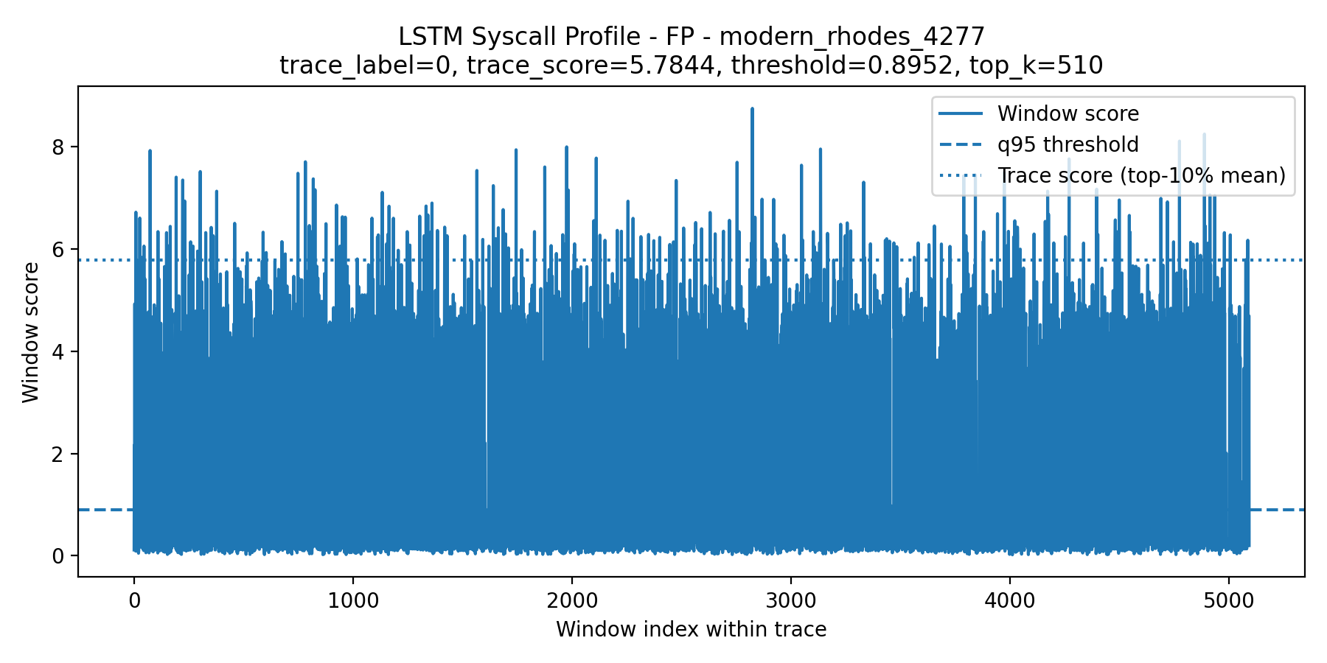
Figure 8 Example false-positive trace profile (q95, LSTM Syscall).

The source code, preprocessing scripts, trained model outputs, additional figures, and demo workflow are available in the project GitHub repository:

GitHub Repository: https://github.com/Emirhanmu/LSTM-Based-HIDS-on-System-Call-Sequences

REFERENCES
References

Bridges, R. A., Glass-Vanderlan, T. R., Iannacone, M. D., Vincent, M. S., & Chen, Q. (2019). A survey of intrusion detection systems leveraging host data. ACM Computing Surveys, 52(6), Article 128. https://doi.org/10.1145/3344382
Creech, G. (2014). Developing a high-accuracy cross platform host-based intrusion detection system capable of reliably detecting zero-day attacks (PhD thesis). UNSW Sydney.
Forrest, S., Hofmeyr, S. A., Somayaji, A., & Longstaff, T. A. (1996). A sense of self for Unix processes. In Proceedings of the 1996 IEEE Symposium on Security and Privacy (pp. 120-128).
Grimmer, M., Kaelble, T., & Rahm, E. (2022). Improving host-based intrusion detection using thread information. In EISA 2021 (CCIS 1403, pp. 159-177). Springer. https://doi.org/10.1007/978-3-030-93956-4_10
Grimmer, M., Rohling, M. M., Kreusel, D., & Ganz, S. (2019). A modern and sophisticated host based intrusion detection data set. 16. Deutscher IT-Sicherheitskongress.
Grimmer, M., Nirsberger, F., Kaelble, T., Schulze, E., Rucks, T., Rohling, M. M., Kreusel, D., & Ganz, S. (2023). Dataset report: LID-DS 2021. In Detection of Intrusions and Malware, and Vulnerability Assessment (pp. 59-74). Springer. https://doi.org/10.1007/978-3-031-35190-7_6
Hofmeyr, S. A., Forrest, S., & Somayaji, A. (1998). Intrusion detection using sequences of system calls. Journal of Computer Security, 6(3), 151-180. https://doi.org/10.3233/JCS-980109
Hoang, X. D., Hu, J., & Bertok, P. (2009). A program-based anomaly intrusion detection scheme using multiple detection engines and fuzzy inference. Journal of Network and Computer Applications, 32(6), 1219-1228. https://doi.org/10.1016/j.jnca.2009.05.004
Hu, J., Yu, X., Qiu, D., & Chen, H.-H. (2009). A simple and efficient hidden Markov model scheme for host-based anomaly intrusion detection. IEEE Network, 23(1), 42-47. https://doi.org/10.1109/MNET.2009.4804323
Kim, G., Yi, H., Lee, J., Paek, Y., & Yoon, S. (2016). LSTM-based system-call language modeling and robust ensemble method for designing host-based intrusion detection systems. arXiv. https://doi.org/10.48550/arXiv.1611.01726
Liao, Y., & Vemuri, V. R. (2003). Host-based intrusion detection using dynamic and static behavioral models. Pattern Recognition, 36(1), 229-243. https://doi.org/10.1016/S0031-3203(02)00026-2
Lv, Y., Wang, C., Huang, M., Liang, H., & Yu, H. (2021). Syscall-BSEM: Behavioral semantics enhancement method of system call sequence for high accurate and robust host intrusion detection. Future Generation Computer Systems, 126, 201-214. https://doi.org/10.1016/j.future.2021.06.030
Park, D., Kim, S., Kwon, H., Shin, D., & Shin, D. (2021). Host-based intrusion detection model using Siamese network. IEEE Access, 9, 76614-76623. https://doi.org/10.1109/ACCESS.2021.3082160
Pendleton, M., & Xu, S. (2017). A dataset generator for next generation system call host intrusion detection systems. In MILCOM 2017 (pp. 231-236). https://doi.org/10.1109/MILCOM.2017.8170835
Rohling, M. M., Grimmer, M., Kreubel, D., Hoffmann, J., & Franczyk, B. (2019). Standardized container virtualization approach for collecting host intrusion detection data. In FedCSIS 2019 (pp. 459-463).
Sekar, R., Bendre, M., Dhurjati, D., & Bollineni, P. (2001). A fast automaton-based method for detecting anomalous program behaviors. In Proceedings of the 2001 IEEE Symposium on Security and Privacy (pp. 144-155). https://doi.org/10.1109/SECPRI.2001.924295
Talhi, C. (2017). An anomaly detection system based on variable N-gram features and one-class SVM. Information and Software Technology, 91, 186-197. https://doi.org/10.1016/j.infsof.2017.07.009
Tan, K. M., & Maxion, R. A. (2002). Why 6? Defining the operational limits of STIDE, an anomaly-based intrusion detector. In Proceedings of the 2002 IEEE Symposium on Security and Privacy (pp. 188-201).
Tandon, G., & Chan, P. K. (2006). On the learning of system call attributes for host-based anomaly detection. International Journal on Artificial Intelligence Tools, 15(6), 875-892.
Wagner, D., & Dean, D. (2001). Intrusion detection via static analysis. In Proceedings of the 2001 IEEE Symposium on Security and Privacy (pp. 156-168). https://doi.org/10.1109/SECPRI.2001.924296
Wagner, D., & Soto, P. (2002). Mimicry attacks on host-based intrusion detection systems. In Proceedings of the 9th ACM Conference on Computer and Communications Security (pp. 255-264). https://doi.org/10.1145/586110.586145
Warrender, C., Forrest, S., & Pearlmutter, B. (1999). Detecting intrusions using system calls: Alternative data models. In Proceedings of the 1999 IEEE Symposium on Security and Privacy (pp. 133-145). https://doi.org/10.1109/SECPRI.1999.766910
Wunderlich, S., Ring, M., Landes, D., & Hotho, A. (2020). Comparison of system call representations for intrusion detection. In CISIS/ICEUTE 2019 (AISC 951, pp. 14-24). Springer. https://doi.org/10.1007/978-3-030-20005-3_2
Xie, M., & Hu, J. (2013). Evaluating host-based anomaly detection systems: A preliminary analysis of ADFA-LD. In 6th IEEE International Congress on Image and Signal Processing (pp. 1711-1716). https://doi.org/10.1109/CISP.2013.6743952
Xie, M., Hu, J., & Slay, J. (2014a). Evaluating host-based anomaly detection systems: Application of the one-class SVM algorithm to ADFA-LD. In 11th International Conference on Fuzzy Systems and Knowledge Discovery (pp. 978-982).
Xie, M., Hu, J., Yu, X., & Chang, E. (2014b). Evaluating host-based anomaly detection systems: Application of the frequency-based algorithms to ADFA-LD. In International Conference on Network and System Security (pp. 542-549). Springer.
Ye, N., Li, X., Chen, Q., Emran, S. M., & Xu, M. (2001). Probabilistic techniques for intrusion detection based on computer audit data. IEEE Transactions on Systems, Man, and Cybernetics-Part A: Systems and Humans, 31(4), 266-274.
Ye, N., Emran, S. M., Chen, Q., & Vilbert, S. (2002). Multivariate statistical analysis of audit trails for host-based intrusion detection. IEEE Transactions on Computers, 51(7), 810-820.

